**Discrete Mathematical Structures**

**Week-12**

**Long Descriptive Questions**

1. **Find the minimum spanning trees of the weighted graph given in the figure below.**

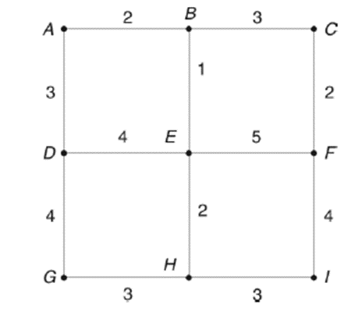

using Kruskal’s algorithm

* The total number of vertices are 9.
* Hence the number of minimum edges to be considered is 9-1 = 8.
* We also must ensure that there is no circuit or loop formation-
* We’ll first draw a table with columns edges, weight, whether we are including the edge and circuit formation

|  |  |  |  |  |
| --- | --- | --- | --- | --- |
| S.No. | Edges | Weights | Included in Spanning Tree | If not, Circuit formed |
| 1 | BE | 1 | Yes | - |
| 2 | AB | 2 | Yes | - |
| 3 | CF | 2 | No | F-E-B-C-F |
| 4 | EH | 2 | Yes | - |
| 5 | AD | 3 | No | D-E-B-A-D |
| 6 | BC | 3 | Yes | - |
| 7 | GH | 3 | Yes | - |
| 8 | HI | 3 | Yes | - |
| 9 | DE | 4 | Yes | - |
| 10 | DG | 4 | No | G-H-E-D-G |
| 11 | FI | 4 | No | I-H-E-F-I |
| 12 | EF | 5 | Yes | - |

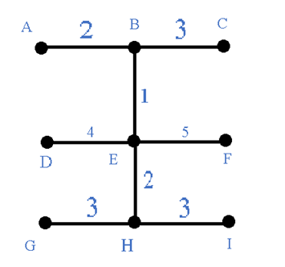

Hence above is the MST of the weighted graph given in the question and total weight will be 23